A

Report

On

World Philosophy Day 2019

Session :2019-20

Department of Philosophy

Rabindra Mahavidyalaya,

champadanga, Hooghly

Theme: World Philosophy Day

Venue: Rabindra Mahavidyalaya

Department of Philosophy

Room no 71

Date:21ST November 2019

Organizer: Department of Philosophy

Objectives:

- To understand and respond to major contemporary challenges by creating the intellectual conditions for change.
- To give a clear understanding of various subjects
- Realizing the Value of philosophy
- For the development of thinking
- Stimulating intercultural dialogue
- Helping build a more tolerant and respectful society
- Revealing other talents

summary

On November 21ST, 2019, World Philosophy Day was celebrated in the Department of Philosophy. By celebrating World Philosophy Day each year, on the third Thursday of November, UNESCO underlines the enduring value of philosophy for the development of human thought, for each culture and for each individual. First, Professor Hasina Sikdar head of the Department the lamp lighting in front of Radhakrishnan's portrait. In the portrait, flowers and garlands were given by prof. Soumitra Das and prof. Sanchita Kheto. 4 teachers and 99 students were present in the event. Then the students performed an opening song. A short cultural program of half an hour with dance, song recital etc. After that begins the educational program. A debate session was organized on this occasion. The topic was ‘existence and non-existence of ATMA’. There were six teams and each team had three students. Students perform very well. The audience enjoyed it very much. They learn a lot.
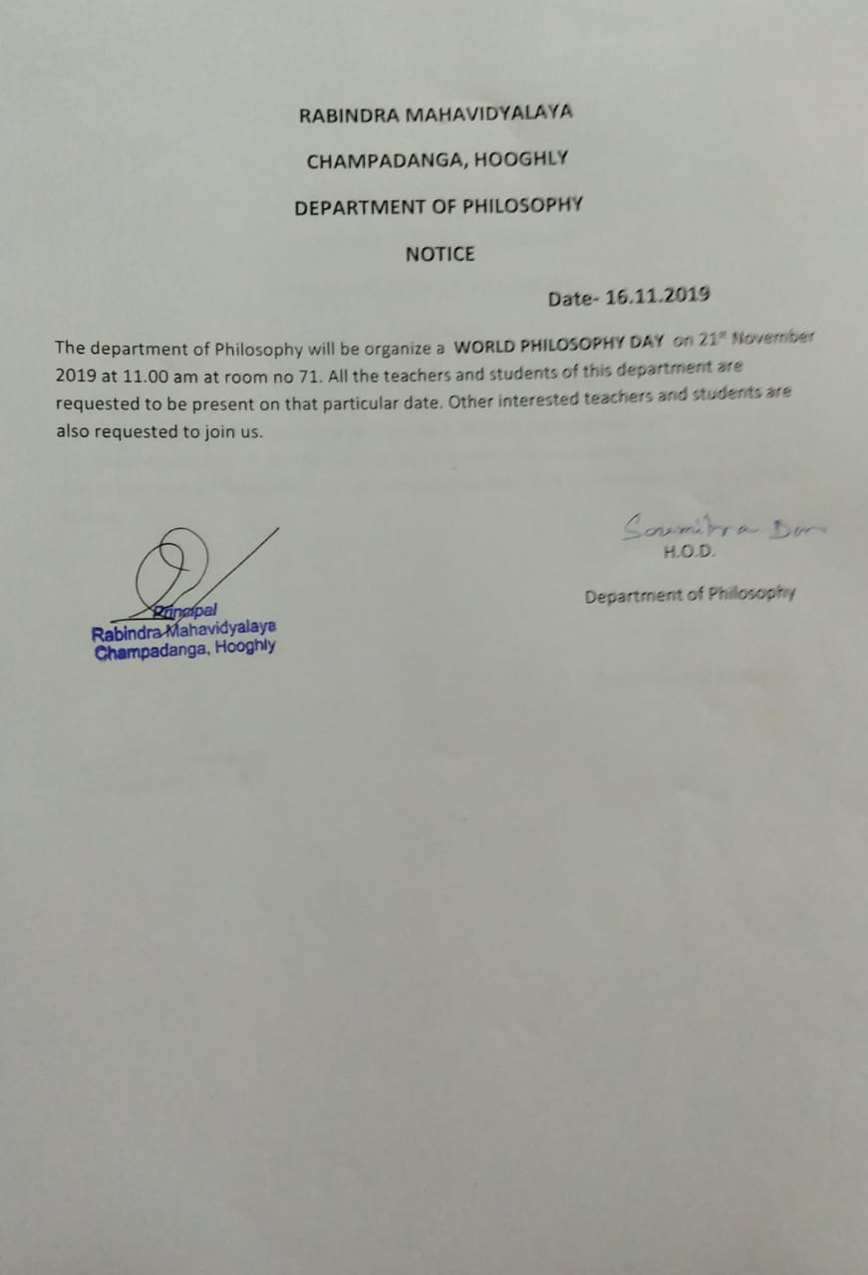

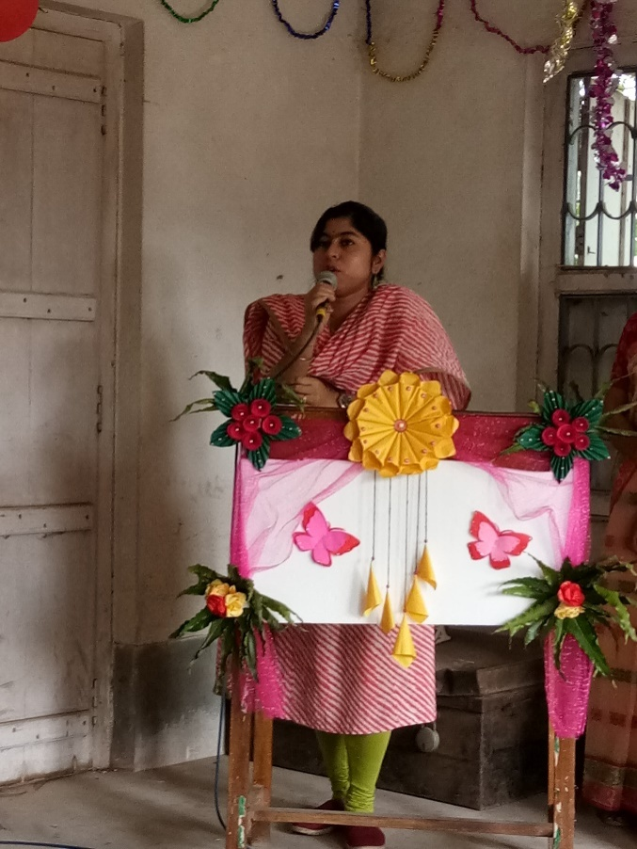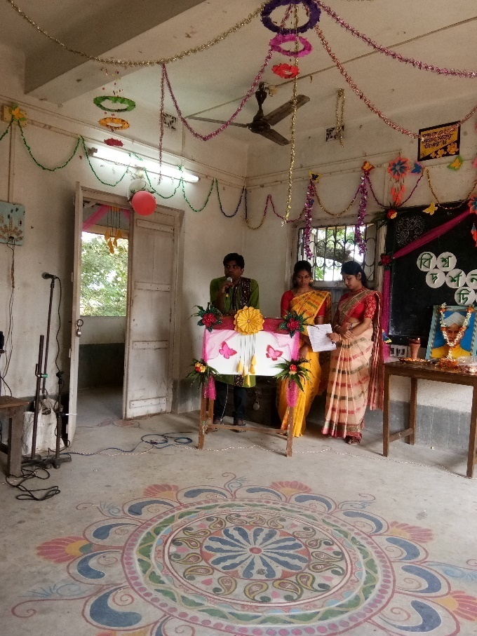
Inaugural speech by department head speech by prof. Soumitra Das

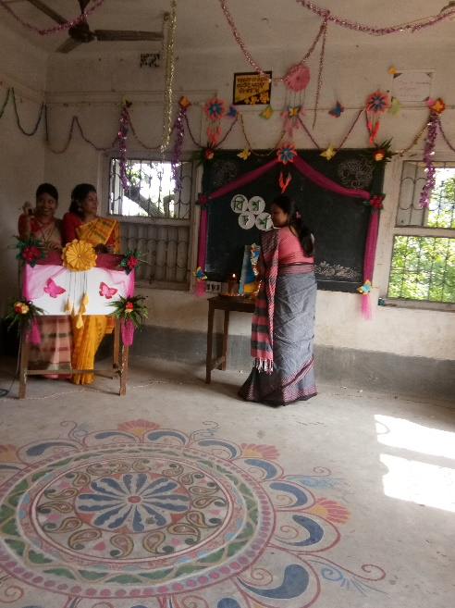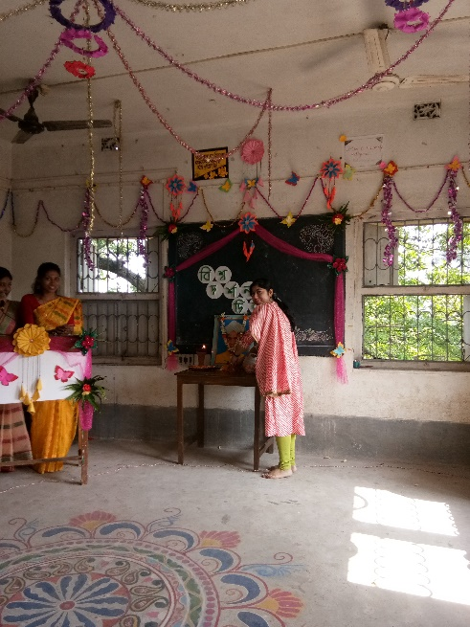
Inaugural session

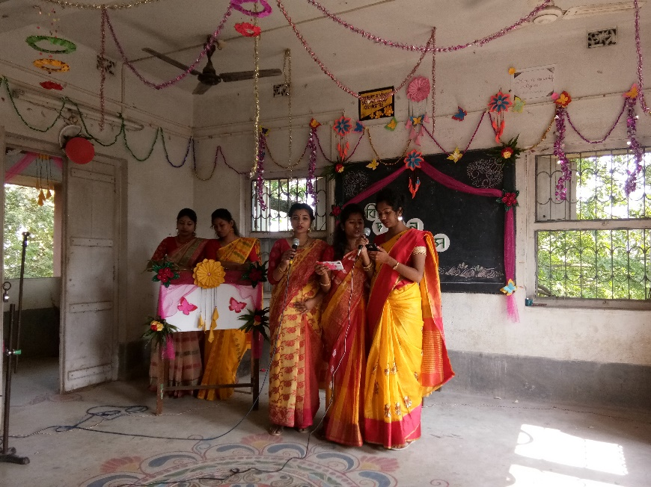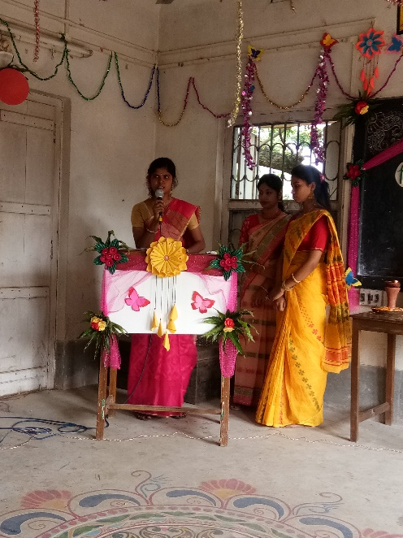
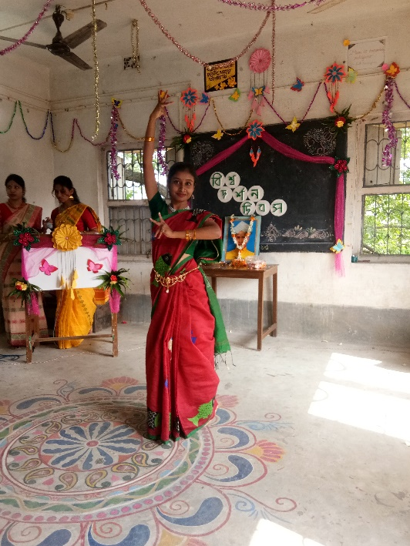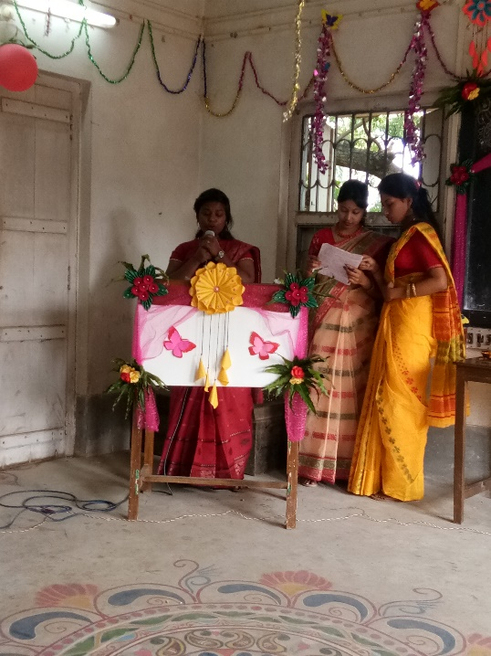
Perform by students
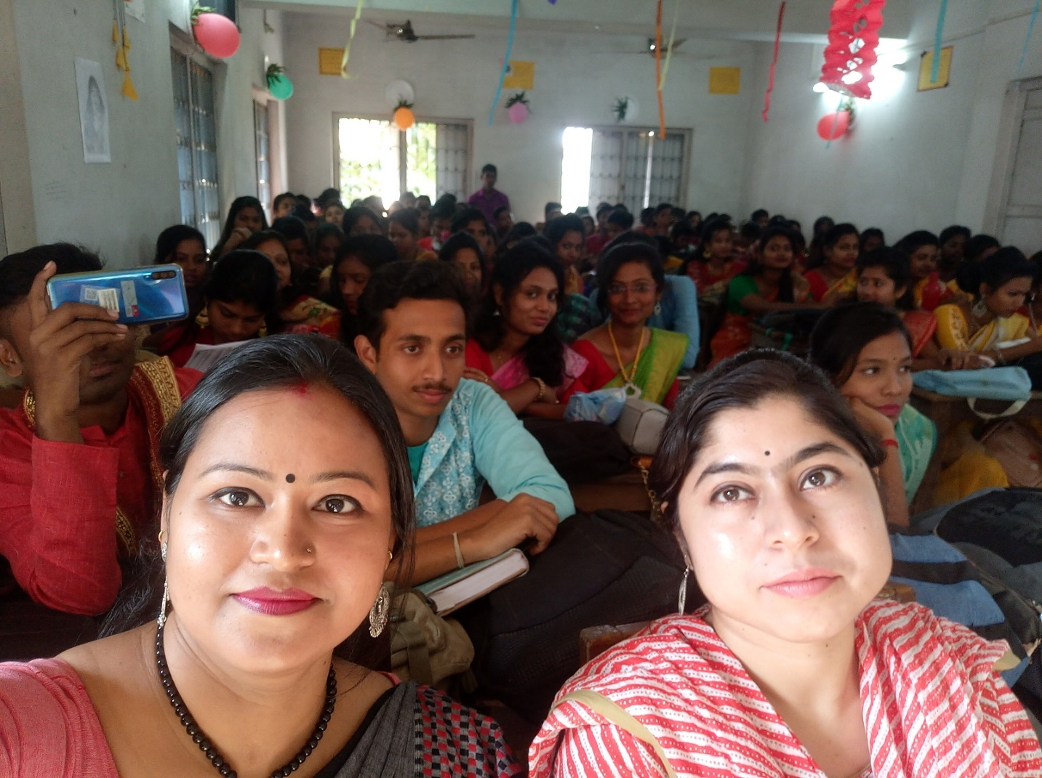

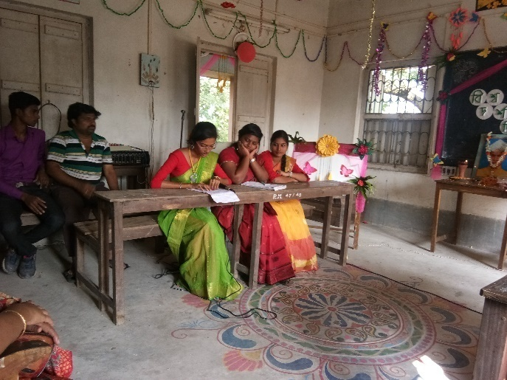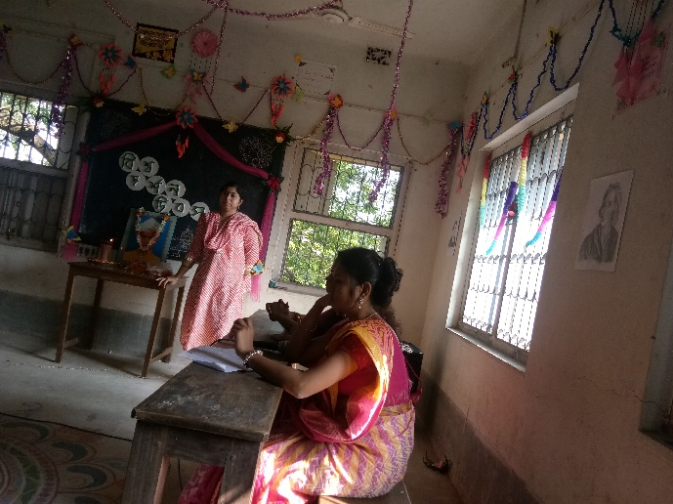

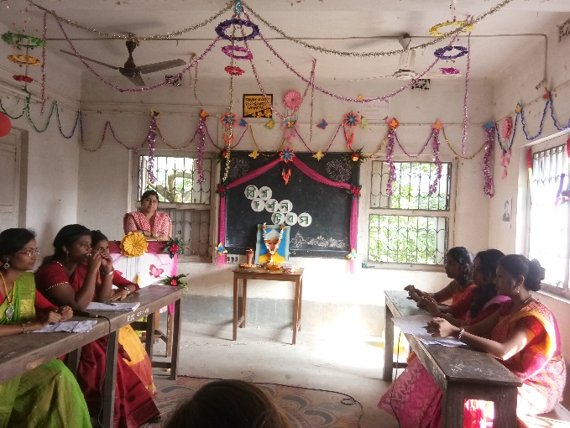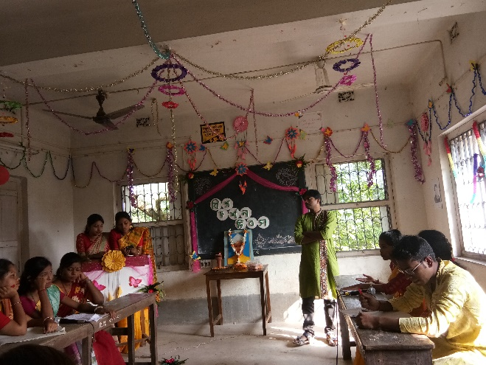
Debate team

Attendance:
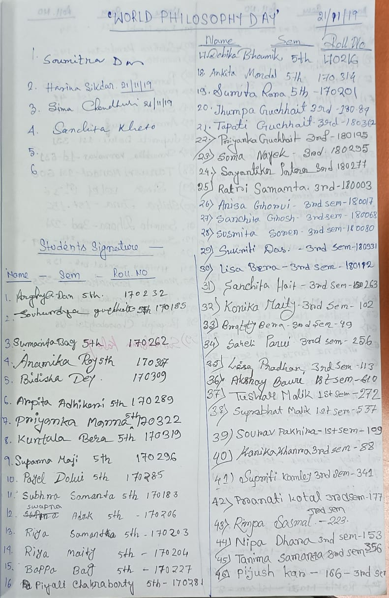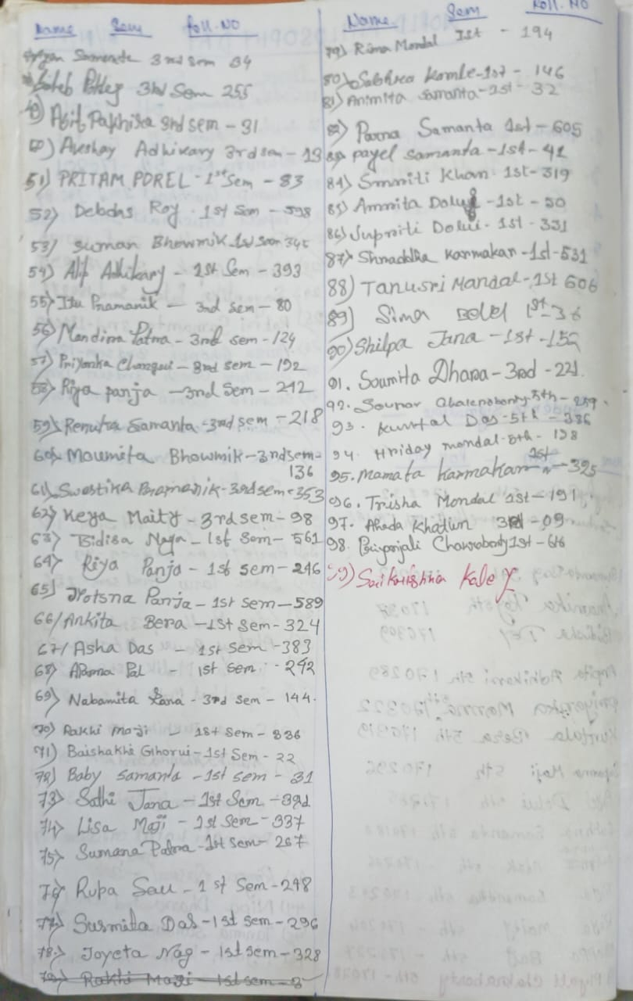

Our participants: 103
Male:21
Female:82

Tentative programmed schedule
- Inaugural session: 11.30a.m. to 11.45a.m.
- Inaugural speech:11.45a.m. to 12 noon
- Other speech: 12noon to 12:30 p.m.
- Cultural programme: 12.30 p.m. to 1.00 p.m.
- Lunch break: 1.00 p.m. to 1:30 p.m.
- Debate: 1:30 p.m. to 3:30 p.m.

Feedback from students:

- 60% felt satisfactory
- 70 percent wished to occur the event more than once every year
- 100 percent students agreed this event helpe to improve their logical performance
- They want special class for grooming, more extra-curricular activities
- They want smart class room

